2020 Titans Award Winners

2020 Top Office Producer (Leasing)- Jared Goodman Cushman & Wakefield

2020 Top Retail Producer (Leasing)- Aki Palmer, Cushman & Wakefield

2020 Top Industrial Producer (Leasing)- Peter Kast, CBRE

2020 Top Rookie Broker of Northern Colorado- Jamie Globelnik, Realtec

2020 Top Land Producer (For Sale)- Ryan Hostetler, AGPROfessionals

2020 Top Investment Producer (For Sale- Office, Retail, Land)- Jared Goodman, Cushman & Wakefield

2020 Top Multi Family Producer (For Sale)- Brian Mannlein, Cushman & Wakefield

2020 Noco Titan Award- Travis Ackerman, Cushman & Wakefield

2020 Notable Deal of the Year- Mike Eyer, CBRE
2020 Notable Deal of the Year- Julius Tabert, CBRE

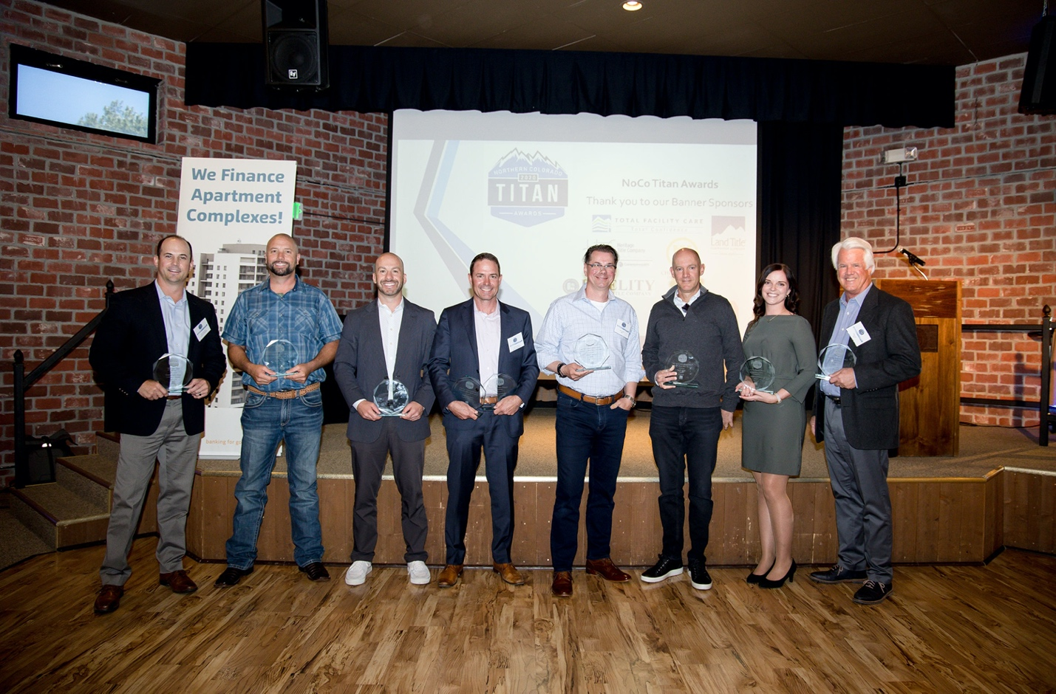
From left to right; Travis Ackerman, Ryan Hostetler, Aki Palmer, Jared Goodman, Julius Tabert, Mike Eyer, Jamie Globelnik and Peter Kast

